Born: 211
Gender: Female
Migration date: mid-spring 227

Personality:
Very religious. Suddenly became baroness, which is very stressful, which she doesn't like. Tries to spin her current life situation to avoid work as much as possible. Thinks she very important. Doesn't care for tradition or fairness. Easily cracks under pressure.
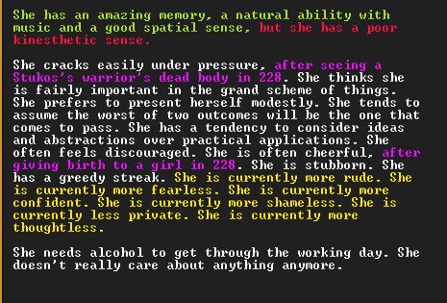
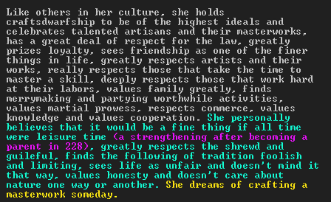
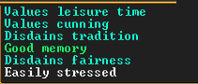

Position:
baroness of Charmpapers – a worthless backwater. Nothing exciting happened there since some trolls caused noise in 165.

Relationships:
Married to Erith Evenedhatchet
Father – Dumed Groupedlances, previous Baron, died in 229 at Bootbegin, was a Baron for around half a year.
He was the son of , the previous Baroness
Mother – Sakzul Futurehelms, alive, administrator at Charmpapers
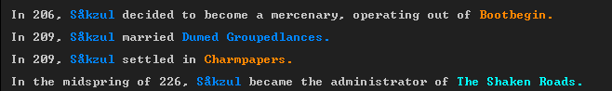
Two kids: Kulet Gemsinews b. 228 and Tosid Indigokeys b. 229

